**Snowfall effect in actionscript 3.0**

E.L- report

I was given the task of creating a piece of flash work that I could essentially learn and put my own twist on it and in this I think I succeeded. I then have went about putting together this tutorial to show the understanding and techniques involved.

**Original**

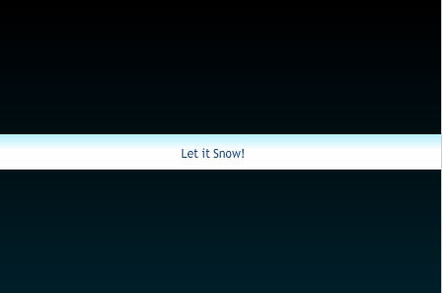

The original flash tutorial from Kipupa.com, it was easy to follow and allowed for the reader to put hid/her own creative spin on it to an extent. Not Following the tutorial completely mine differs in some ways as I tried my hand at branching out to other weather animations such as rain which worked fairly well.

The tutorial shows how to create and use circles to portray a snowfall effect. It does this firstly creating a single circle in an actionscript(AS) file named fallingSnow. By creating the single snowflake using the circle tool and converting it to a symbol named Snowflake. Making it a movieClip as well. Then also ticking the Export for actionscript box. This is so we can have a class file associated with the snowflake.

Snowflake is then called by our next AS class we create called Snowflake also . A new file which contains the AS for the process is named Snowflake also, the Script in use allows for many things. It firstly tells the snowflake where to randomly appear, the size and rotation. Most of the random numbers are generated by Math.random which is multiplied by usually, scaleX as Math.random only produces numbers between 0.0 and 1.0. 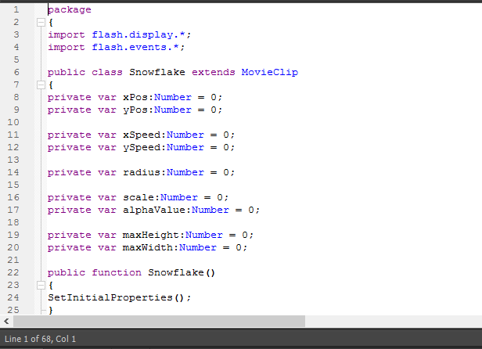

Briefly going through the code the “public class Snowflake extends MovieClip”, this is the main part that links and refers back to the previous symbol that we created in our Snowfall file. 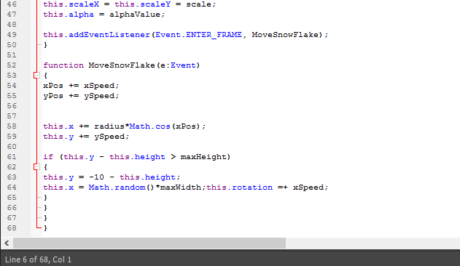

These values such as “xSpeed, ySpeed, radius” are all created and given null values so that we can overwrite them later with random ones to vary each snowflake that is created.

Calling the “setInitialProperties()” sets the variables for a snowflake. The function “setInitialProperties()” we created just below which creates these random values for each variable using Math.random() which I mentioned earlier.

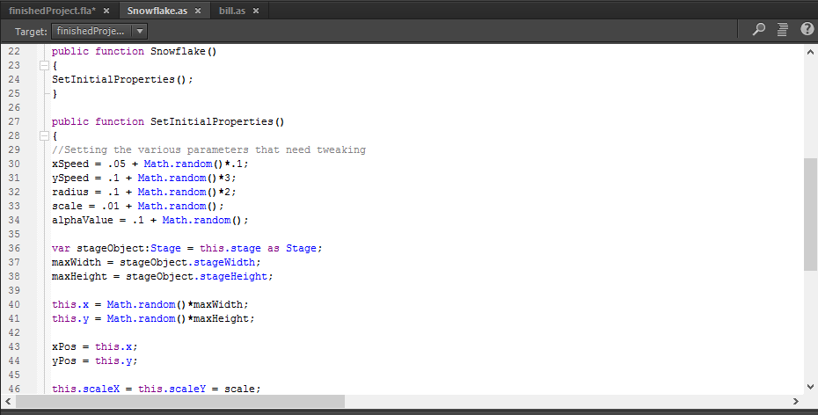Once the code is in place and working the single snowflake should be seen falling from the top of the screen and fall away.

The easiest way to make multiple snowflakes is copy and pasting over the stage, probably the fastest too but of course there is the option of coding in it into the fallingSnow.swf. I took the copy and pasting approach in my project.

Following the tutorial and giving the basic overview and detail of hoe it works and was put together I will show my version and how I tweaked it and probably got carried away with it.

**My finished version and how I arrived at it**

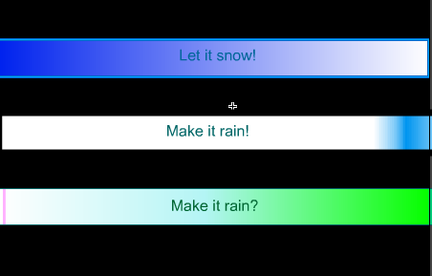

At first glance at my page you are greeted with three buttons each of which has their own effect. I done all this across 20 frames but with lots of layers to stay organised such as the actions layer I Kept track of strictly the actionscript and another for text that went over my buttons. That said luckily the snowfall and Money fall options used only one keyframe, The rain however I used a looped animation that was roughly across ten frames.

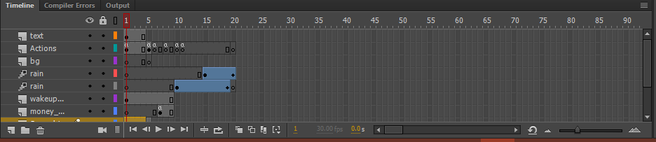

For my version of the snowfall is it followed the same technique as the tutorial but what I did is edited the symbol of the plain circle. I then began changing it to something more snowflake like, and I came out with a better image. This was better if course cause the rotation could be seen now as it couldn’t before as it was just a plain circle.

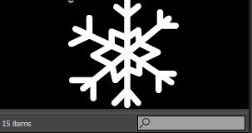

The second option I created was the “make it rain!” I started of by creating one rain drop and converted it into a symbol. Making it a graphic this time. Of course creating a new layer to work with I looked at how I could get my rain from one end to the other and found a motion tween to be the best solution.

Once the drop is created move it to the top above the stage. Then in the timeline in the layer you’ve dedicated to the rain create ten frames. Right click and select Motion tween on the tenth frame. Select your drop and place it below the stage. You can then see the vague line of where the drop will cross the stage.

That done the ten frames played with the one drop falling. We copy and paste several more of those drops. We then make this group of raindrops a symbol and tween all at once creating the rain effect.

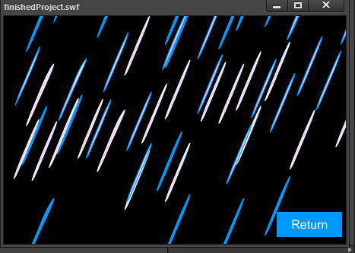

.The last option labelled “make it rain?” I put in simply cause the reward for getting it to work was worth it in the end and put a less serious spin on it and hopefully humorous. I imported a PNG of a dollar bill which I edited out the background in photoshop so that it wouldn’t ruin the whole experience of being showered in money. The bill can be found on google images easily and isn’t necessary to photoshop.

How I went about this was that I created a Keyframe such as snowflake and place my single dollar bill. Converting this to a symbol and naming the instance “bill” Making it a MovieClip and exporting for actionscript similar the snowflake class. Creating an actionscript class. This time with changes so that it can alter my bill and not the snowflake.

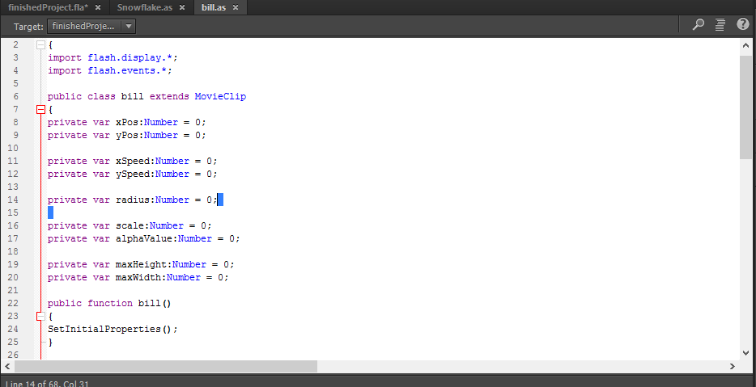

This done we simply copy and paste an adequate amount of those bills onto the stage and we are good to go!. Now we see that the money falls just like the snow and it works.

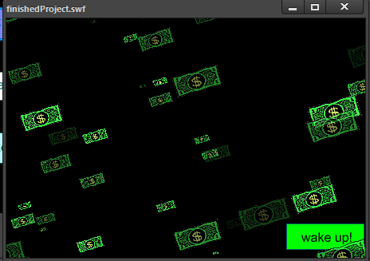

**Buttons and navigation**

All the buttons were created easily and effectively. First you create a shape giving it a colour and then placing the text over it. Selecting the shape, we convert it to a symbol (button) and I like to keep the name and instance name the same so in the case above I named it “Wakeup_btn”

At the main menu the actionscript is kept on the first frame. Each button had the code that when it is clicked it goes to that frame.

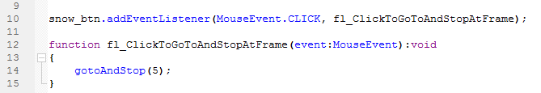

**Th**is code is easily found in the code snippets menu and can be applied easily by seclecting a button then windows/codeSnippets/timeline navigation/ClickToGoToFrameAndStop

For both snow and the money effects ,the code “stop()” is present on there keyframes otherwise it would run throught the timeline. Unlike rain which is at the end of the timeline so as it plays out it reaches the end then repeats from the start of the rain animation again.

**Difficulties**

The difficulties that I found going through this was definitely the classes and use of the external actionscript. Making little naming mistakes resulted in error: 1064 which I ended up not finding and started fresh but luckily worked out and I was more careful with my naming further on.

What I also found difficult was changing the external actionscript so that it worked on a different symbol. For example, the last falling money I used the snowfall actionscript creating a similar class with the exception I changed it to affect the new dollar bill that I was using.

A small thing I noticed is my first button the mouse, the pointer didn’t change but was working properly. I found then had it as a movie clip instead of a button and fixed it easily. And I hadn’t considered it too much but if it was of greater significance it could have caused worse problems.

**What I found easy**

What I found was definitely the timeline navigation and the button creations. Although I had many layers for everything it was more organised in a sense and less of a risk if things had to be deleted. That said things were easier when I had to delete and do them again properly.

Other than that I didn’t aim to pick a project or make a project that was easy. I picked something that was what I thought would be fun and I could put my own twist on while also learning more about actionscript and just how versatile it can be.

**What I learned**

I learned a lot of small things such as motion tweeking simple things. The main thing was changing the actionscript in the right places so that I wanted it to do what I wanted. Understanding what the code did was easier after changed it around.

In conclusion I’m happy with the outcome, I think I took the tutorial and made my own creative changes and even expanded a little bit. I think that it is a fun little piece to do and hopefully teaches someone something they didn’t know previous.

The effects can be used over and over again. It’s very rewarding watching it all come together and it is only limited by a persons creativity.

The files are available to download and view: <https://www.dropbox.com/sh/c5w62tkn93dc600/AABlxr1Hsbx4D4Llq_FTuWdUa?dl=0>

https://snowfallcs270.blogspot.ie/2017/03/snowfall-effect-inactionscript-3.html